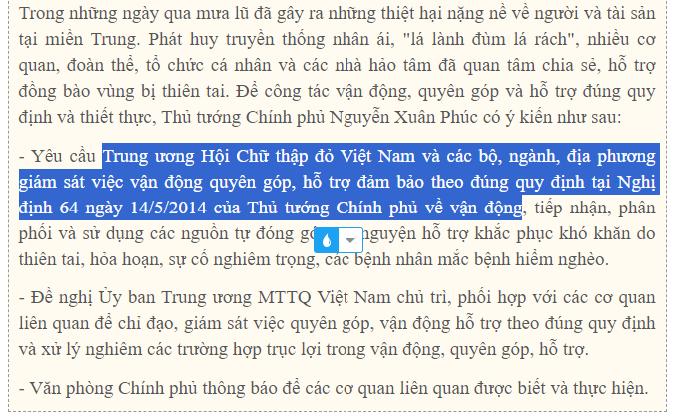

* Tài liệu ngoài lề

<https://vtv.vn/xa-hoi/lam-sao-de-hang-cuu-tro-dong-bao-bi-lu-lut-den-dung-nguoi-phan-bo-hop-ly-20201021182926763.htm>

<https://thuvienphapluat.vn/van-ban/Bo-may-hanh-chinh/Nghi-dinh-64-2014-ND-CP-huong-dan-Luat-Tiep-cong-dan-237609.aspx>

<https://baophapluat.vn/tiep-nhan-tien-tu-thien-the-nao-cho-hieu-qua-va-dung-luat-post488142.html> -

* Quy định về phân phối nguồn đông góp từ thiện

<https://thuvienphapluat.vn/van-ban/Tai-nguyen-Moi-truong/Nghi-dinh-93-2021-ND-CP-phan-phoi-su-dung-nguon-dong-gop-tu-nguyen-ho-tro-thien-tai-dich-benh-460767.aspx>



